All about my emotions
Task: Copy and Paste the following emoji pictures to match with the
correct emotion.
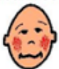 |  |  | 
 |  |  | 

Emotion | Face
Happy
Sad
Excited
Embarrassed
Proud
Sorry
Angry
Surprised

