Show and Not Tell Emotions
Task 1: Copy and Paste the following emoji pictures to match with the
correct emotion.

Angry | Happy | Embarrassed
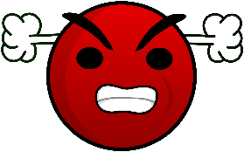 |  | 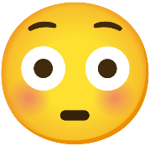

Emotion | Emoji
Smiling
Hands forward in fists
Hiding their face with long hair
Face goes red
Eyes wide and glaring
Talkative
Louder annoyed voice
Friendly
Task 2: Cut and Paste the following emotions under their correct emoji.
Flinching at noises
Watery eyes
Big smiles
Hugging
Avoiding other’s eye
Shaking
Crying, not wanting to talk
Cold sweat

Sadness  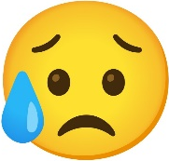 | Excitement  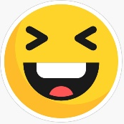 | Afraid  

