Show and Not Tell Emotions 2
Task 1: Copy and Paste the following emoji pictures to match with the
correct emotion.

Anxious | Happy | Sad | Scared
 |  | 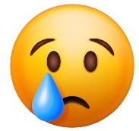 | 

Situation | Emoji
We just won a trip to Disney World and we leave tomorrow! I feel…
The fire alarm just went off and I was not expecting it. I feel…
I am not looking forward to going to the dentist tomorrow. I feel…
That huge spider just jumped right onto my shoulder! I feel…
My class just won a pizza party for collecting funds for charity. I feel…
My dog Max died last week.
I have to give a presentation in front of the entire class. My hands are shaking. I feel…
My sister just gave me the best birthday present! I feel…
Task 2: Cut and Paste the following emotions under their correct emoji.
Poorly
Cold
Astonished
Sad
Scared
Embarrassed

 |  | 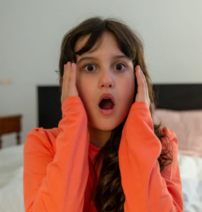
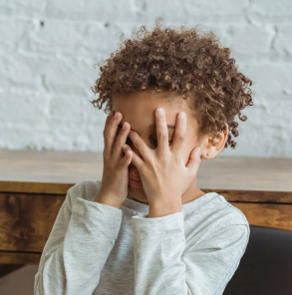 |  | 
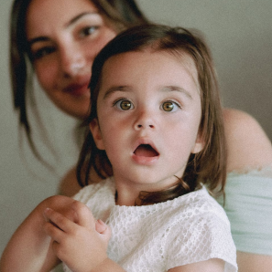 |  | 

